11.Credit Score Classification using Machine Learning

Aim
To implement a Credit Score Classification program in Python using a machine learning algorithm and classify customers into different credit score categories.

Algorithm
- Import the required libraries.
- Create the dataset containing customer features and credit score classes.
- Separate the input features and target class.
- Split the dataset into training and testing data.
- Train the classification model using the training data.
- Predict the credit score class for the test data.
- Calculate the accuracy of the model.
- Display the actual and predicted results.
Program:
from sklearn.tree import DecisionTreeClassifier
from sklearn.model_selection import train_test_split
from sklearn.metrics import accuracy_score
X = [
[25, 30000, 1],
[30, 40000, 2],
[35, 50000, 3],
[40, 60000, 4],
[45, 70000, 5],
[50, 80000, 6],
[28, 35000, 1],
[38, 55000, 3],
[48, 75000, 5],
[55, 90000, 6]
]

y = [
"Poor",
"Poor",
"Average",
"Average",
"Good",
"Good",
"Poor",
"Average",
"Good",
"Good"
]
X_train, X_test, y_train, y_test = train_test_split(
X, y, test_size=0.3, random_state=42
)
model = DecisionTreeClassifier(random_state=42)
model.fit(X_train, y_train)
y_pred = model.predict(X_test)
print("Actual Credit Scores:", y_test)
print("Predicted Credit Scores:", y_pred)
accuracy = accuracy_score(y_test, y_pred)
print("Accuracy:", accuracy * 100, "%")
new_customer = [[32, 45000, 2]]
prediction = model.predict(new_customer)
print("New Customer Credit Score:", prediction[0])
OUTPUT:
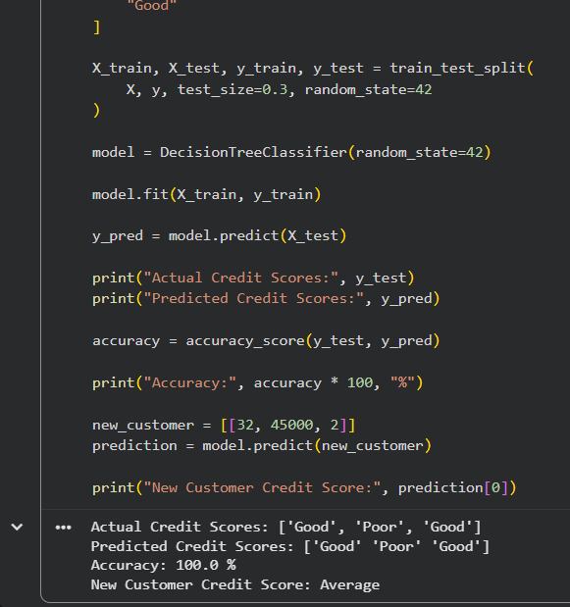
RESULT:
Thus, the Credit Score Classification task was successfully implemented using a Decision Tree Classifier in Python, and the credit score category of a new customer was successfully predicted.

